Pass Task 9 - Counter

# Related Learning Outcomes

# ULO1 – Explain the OO Principles

This exercise demonstrated the ability to draw many shapes through new code that could manage a collection of shapes. The class created could manage and draw multiple shapes wit hthe ability to add, remove, select and draw new shapes.

Learnt about aggregation showing the relationship between the different classes.

Learnt how to use lists to store the objects. The Task demonstrated using multiple constructors with different parameters to get different results such as how default settings work.

# ULO2 – Use OO Language and Library

Demonstrated class, method, field and constructor declaration. We used the library in accessing System.Collections.Generic. Learnt about class libraries that include number of classes that can be used to create objects in the program. The task specifically taught about managing collections of objects. The collection object maintains a number of objects for you. The list type of class can add, remove and fetch objects from the list for you.

# ULO3 – Design, Develop and Test using an IDE

The code was developed using Xamarin Studio to build and run the program, as well as integrated debugging features to step and inspect values. Learnt how to use the IDE to add methods. Demonstrated use of NUnit to test and debug the game to make sure everything was working correctly and how to add a method based on the Test class.

# ULO4 – Communicate using UML Diagrams

I learned how to interpret a UML class diagram and write the related code.

# ULO5 – Describe Elements of Good OO Design

The exercise demonstrated correct use of C# coding conventions.

# Screenshots

[code running]

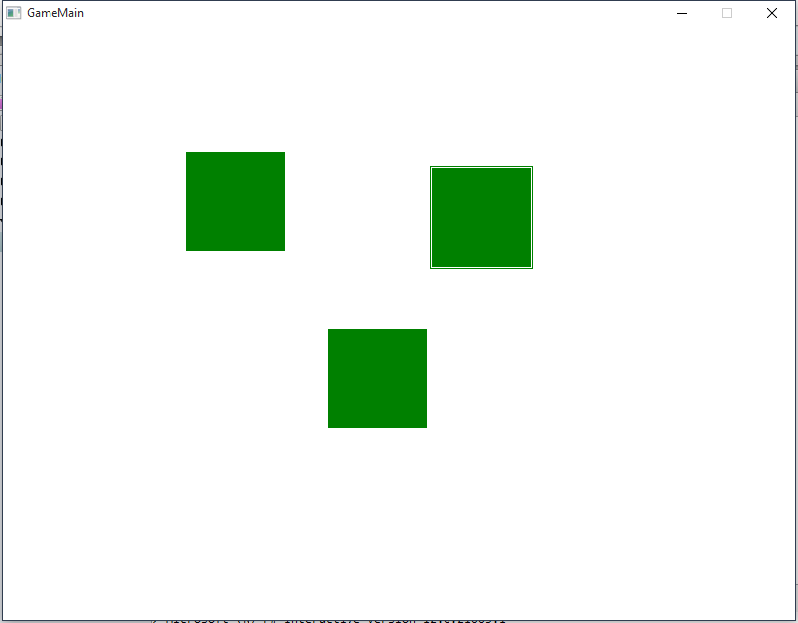

[use of IDE]

